Wildlife Conservation Option

School of Environmental and Forest Sciences

University of Washington

Box 352100

Seattle, Washington 98195-2100

**SENIOR THESIS PROPOSAL**

**ESRM 494**

*Draft*

TO: Sarah J. Converse

TITLE OF PROPOSED PROJECT: Relationship between Scripps’s Murrelets egg size and marine conditions at Santa Barbara Island (Working title)

STUDENT'S NAME: Marcela Todd Zaragoza

DATE: February 26, 2021

**Abstract**

I will investigate the effects of oceanographic conditions on Scripps's Murrelets (*Synthliboramphus scrippsi*) egg size at Santa Barbara Island, California, USA, from 2009-2017. Environmental covariates, including sea surface temperature, coastal upwelling indices, the Pacific Decadal Oscillation index, the El Niño/Southern Oscillation index, and forage fish abundance catch-per-unit-effort indices from California Cooperative Oceanic Fisheries Investigations surveys will be included in this analysis. Scripps's Murrelets lay eggs that are relatively large to their body size and must therefore gain resources from their environmental surroundings to accomplish this. The goal of this research to understand which factors, if any, are driving variance in egg sizes. Using linear mixed models that include environmental covariates and egg-laying order as fixed effects and random plot and observer effects, I will model these relationships. The importance of collecting this egg measurement data at Santa Barbara Island is unknown and could potentially be taking up resources, including time and observer effort, as well as disrupting sites and breeding birds. Therefore, gaining an understanding of the level of importance of collecting this data for population monitoring and conservation efforts will be beneficial for future endeavors.

**Introduction**

Seabirds have previously been identified as reliable indicators of marine ecosystem health (Mallory et. al, 2010, Cairns 1986). Fluctuating marine conditions can impact demographic processes of seabirds due to their dependence on marine ecosystems for foraging, nesting, and other life processes. For example, Caussin’s Auklets at Triangle Island (British Columbia, Canada), have shown reduced offspring survival and fledging masses in years of warm sea surface temperatures (SSTs) due to limited temporal overlap between pre-breeding foraging and prey availability (Hipfner, 2008). Examining the relationship between marine conditions and direct reproductive parameters is a challenging task due to the varying scales on which these processes operate on.

Changes in marine conditions have previously been linked to declines in reproductive success (Hipfner 2012) and changes in clutch size (Roth et. al, 2005) of seabirds. Egg size can be a measure of productivity and reproductive success and can therefore be linked to overall population trends. Interannual and interdecadal oceanographic variations have demonstrated to play an essential role in the egg size of seabirds. In Norway, Atlantic puffin populations at two separate colonies (1980-2011) showed an annual decrease in population and parallel decreases in egg volume (Barrett et. al 2012). The relationship was modeled using regional (winter North Atlantic Oscillation [wNAO]) and local (April SST) oceanographic conditions that linked a lack of food availability prior to egg-laying to decreases in egg size. Furthermore, Herring gulls in the Grand Manan Archipelago in the Bay of Fundy, Canada displayed increased egg volume correlated with weak interactions with SST and the wNAO. In general, egg size varies with the amount of energy invested into egg production and such can be reflected by environmental parameters (Williams 2005) .

Santa Barbara Island (SBI) is the smallest island in the Channel Islands National Park in California and supports the largest population of Scripps’s Murrelets (*Synthliboramphus scrippsi*; SCMU) in the United States (~475-650 breeding pairs). Relationships between marine conditions and SCMU breeding success has been limited to looking at ocean productivity and SCMU clutches which revealed that higher ocean productivity leads to earlier clutch initiation dates and higher clutch sizes (Roth et al, 2005). However, there has not been any work directly linking oceanographic conditions to egg size. SCMU eggs represent 23.7% of the female body mass, making them one of the largest relative to body weight in the Alcidae family (Sealy 1975). Furthermore, after the first egg is laid, incubation is delayed until clutch completion so that both chicks can leave the nest soon after hatching. This precociality that SCMU chicks display requires large eggs and in order to obtain the necessary nutrients, females must forage several days before laying each egg (Murray et. al, 1983). SBI is located in the Southern California Bight which is highly dynamic and experiences interannual fluctuations in ocean productivity (Thomsen et. al, 2015) and therefore provides an opportunity to look at the ways in which these factors can influence SCMU egg size. By looking at regional environmental patterns in the Northeast Pacific Ocean (Pacific Decadal Oscillation and El Nino Southern Oscillation) and more local patterns (SST and forage fish populations), this research will determine environmental factors that are important for predicting murrelet egg size.

**Research objectives**

1. Examine the relationship between egg size and environmental conditions at Santa Barbara Island.
2. Investigate inherent differences in the size of the first and second egg laid in a clutch.
3. Determine the relative contribution of variance in egg size due to random effects (observer and plot).
4. Evaluate the importance of collecting egg size information in monitoring protocol.

Through this analysis, information will be obtained about the relationships between marine conditions and egg size at Santa Barbara Island. I hypothesize better environmental conditions, which includes better foraging opportunities, will result in larger egg sizes. I also hypothesize there will be inherent differences between the first and second egg laid and that random effects will contribute to the variance in egg size. Lastly, I predict this research will reveal new information about the importance of egg monitoring at SBI which will add valuable information for SCMU population monitoring in the future.

**Proposed Methods**

*Data collection*

Santa Barbara Island (33.4756° N, 119.0373° W) is the smallest (2.6 $km^{2}$) of the eight California Channel Islands and it provides the largest breeding habitat for SCMU. The data used for this analysis were part of a larger project largely funded by the Montrose Settlements Restoration Program at Channel Islands National Park. Data were collected from 2009-2017 in the breeding season which lasts from March to June and peaks in April (Murray et. al, 1983). In order to obtain egg measurements, eggs were first deemed accessible if they were within safe reach of the observer and no adult bird was present at the site. Eggs were then removed from the site, marked with a permanent marker, and measured using Vernier calipers. Egg length and width (at the widest point) were obtained to the nearest millimeter. After measurements were obtained, the egg was returned to its original position and orientation. Eggs were only measured once at each site. “Egg order” was recorded as either “Yes” or “No” if it could be distinguished whether egg 1 was laid before egg 2. Therefore, if both eggs were present at the site upon first encounter, egg order was marked as “No.” The plots used in this analysis include: Arch Point North Cliffs (APNC), Bunkhouse (BH), Boxthorn (BT), Cat Canyon (CC), Dock (DO), Elephant Seal Cove (ESC), Landing Cove (LC), and West Cliffs (WC).

*Covariates*

A suite of covariates will be fitted to investigate the effect of environmental conditions on egg size. These include sea surface temperature (SST), coastal upwelling indices, the Pacific Decadal Oscillation index (PDO), the El Niño/Southern Oscillation index, and forage fish abundance catch-per-unit-effort indices from California Cooperative Oceanic Fisheries Investigations (CalCOFI). All covariates will be standardized such that they are on the same scale and equally contribute to the results. Due to the type of covariates being fitted and the possibility of existing relationships (e.g., fish abundance is often related to upwelling), covariate collinearity will be tested to avoid conflating model results and to obtain accurate model statistical power.

*Model formulation*

I will develop a set of models to investigate the relationship between environmental covariates and egg size. Egg size will be modeled as a linear mixed model with normal errors and multiple random processes. By modeling these random effects, I hope to account for the inherent variability that is associated with different observers operating independently and the location, accessibility, and microclimate of each plot. Additionally, egg order will also be modeled as a fixed effect to try to understand whether that is a determinant of egg size. Using this set of models, model selection will be performed via Akaike’s Information Criterion (AIC) to find the top supported model(s) or the likelihood-ratio-test because of the possibility of nested models.

$y_{i}$ ~ N($μ, {σ^{2}}_{y}$)

$y_{i,t}= β_{0} + β_{1}x_{1} + ... + β_{k}x_{k}+ β_{eggorder}x_{eggorder} + α_{p }+ α_{o }+ α_{t }+ ε_{}$

$α_{p}$ ~ N($0, {σ^{2}}_{α_{p}}$)

$α_{t}$ ~ N($0, {σ^{2}}_{α_{t}}$)

$α_{o }$ ~ N($0, {σ^{2}}_{α_{o}}$)

$ϵ_{}$ ~ N($0, {σ^{2}}_{}$)

where $y_{i,t}$ is the egg size at a given nest *i* and year *t*

$β_{0}$ is the intercept

*k* is X for the X potential predictors

$α_{p}$ is the random effect for plot

$α_{o}$ is the random effect for observer

$α_{t}$ is the random effect for year

$ϵ_{}$ is the error term

*Initial Analysis*

Egg size is the product of egg length and egg width for each egg. There are several values that appear to be outliers which will have to be further examined to determine whether they should be omitted from the analysis (Figures 1 and 2). Upon first inspection of the data, there are 767 values for egg 1 size and 249 values for egg 2 size. The plots with the most entries are APNC (139), LC (298), and CC (305) and there are a total of 27 different observers. Just by looking at the boxplot of egg 1 and 2 values, there does not appear to be much variation between years (Figure 3). Mean egg 1 size is 1891.134 and mean egg 2 size is 1920.885. The initial analysis of the data reveals that there are likely inherent differences between egg sizes, plots, years, and observers that will be interesting to look at when fitting environmental covariates through further work.

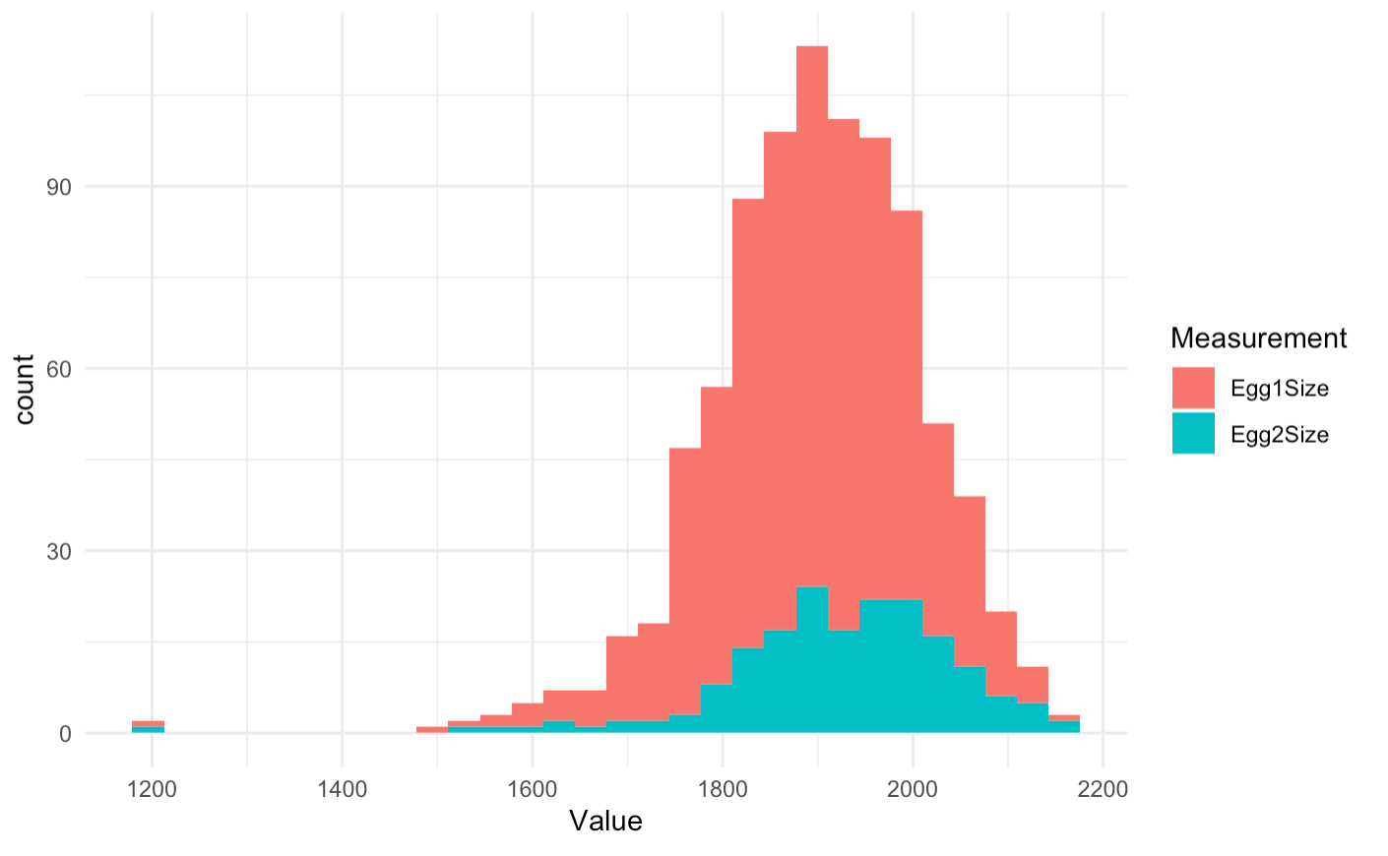

Figure 1. Distribution of the count of egg size values for egg 1 and egg 2.

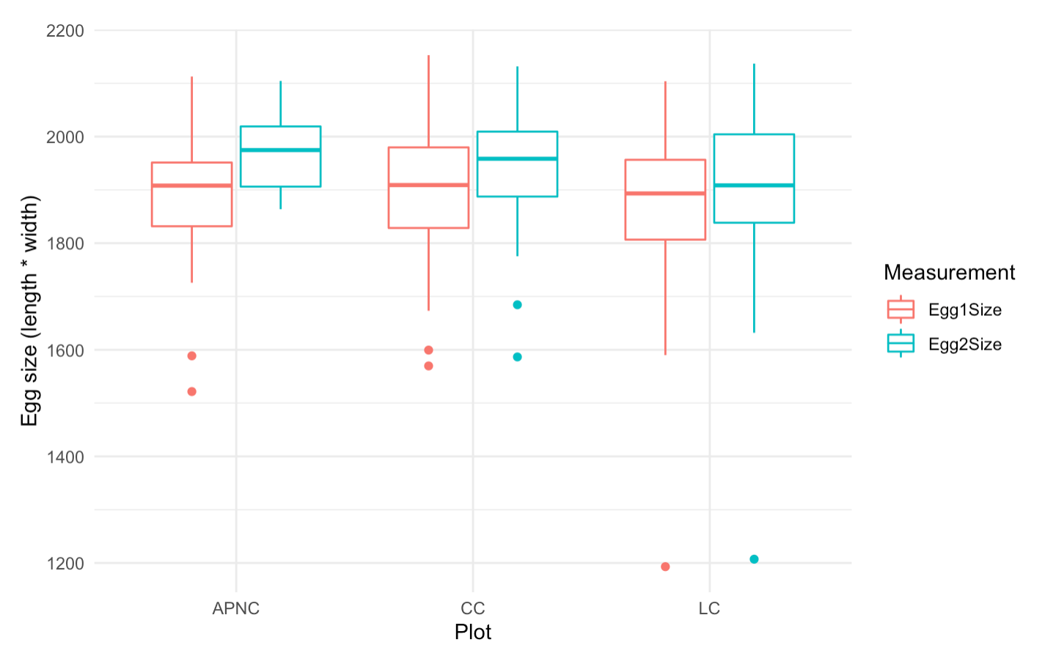

Figure 2. Egg size differences between the plots with the most records (APNC, CC, and LC).

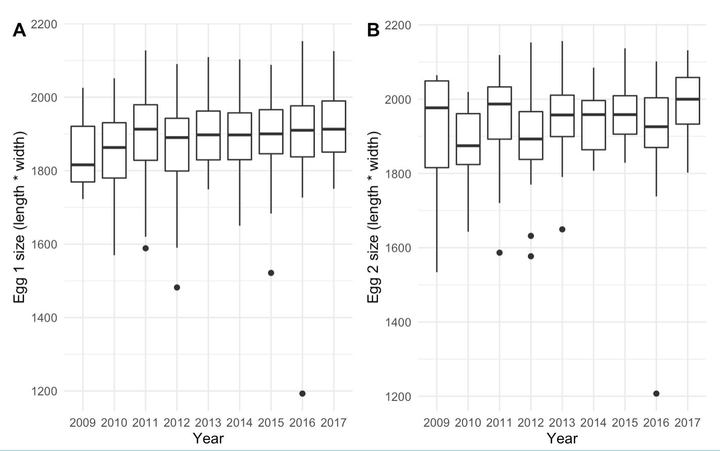

Figure 3. (A) Egg 1 size values from 2009-2017. (B) Egg 2 size values.

**Anticipated outcomes**

I hypothesize that there will be some significant relationship between regional and local marine conditions and egg size throughout the years. More specifically, during ENSO years that result in warmer sea surface temperature, reduced upwelling, and reduced foraging opportunities, egg size values will be smaller. This is mainly due to the fact that SCMUs invest a lot of energy into their eggs in order for precocial chicks to hatch and thus they must rely on their dynamic marine environment to gain those resources. Hence, fluctuations in the marine conditions will likely reflect fluctuations in egg size. Secondly, I predict that egg order will explain some of the inherent variability in egg size between the first and second egg laid as the second egg of a clutch is approximately 1 gram heavier than the first (Murray et. al, 1983). Thirdly, I predict that observer and plot random effects will contribute to the variance in egg size. I believe this will be the case as the plots included in the analysis vary in accessibility and observers have different experience levels when conducting these measurements. For example, the 2012 SBI Final Report talks about how APNC, one of the three plots with the most data points, is hard to monitor and requires skilled observers which could influence egg data collection. Furthermore, the initial data analysis revealed that there were differences in the number of records each observer made ranging from 1 to 234 individual observations. Lastly, although there have been efforts to collect egg measurement data at SBI for many years, no analysis of those measurements has been conducted. This research will provide an initial step towards understanding the importance of collecting this monitoring data as it requires significant time and effort, and could potentially be disrupting SCMU breeding through the direct handling of eggs.

**Research Timetable**

|  |  |
| --- | --- |
| **Tasks** | **Time allocation** |
| Data collection | Completed |
| Data analysis | 2-3 weeks at the beginning of Spring Quarter (March) |
| Thesis   * Initial draft will be turned in for revision to AJD * Revised draft to SJC | 3 weeks   * Work on draft: Weeks 4 through 7 * Turn in draft by week 7 * Revisions returned by week 8-9 * Make edits and turn in at the end of the quarter |
| Poster presentation | 2 weeks   * Presentations week 9/10 |

**Literature Cited**

*will add before submitting to Sarah*